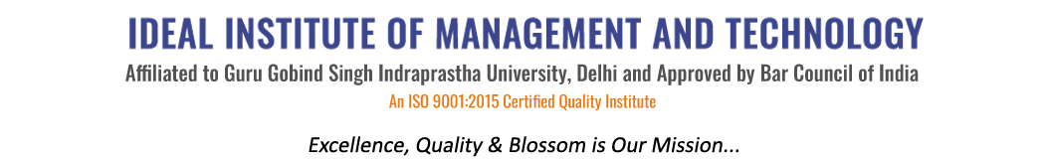
16 X, Karkardooma Institutional Area, (Near Telephone Exchange)
Delhi-110092
+91 (11) 22372639, 22375961,
http://idealinstitute.edu.in

Date: 16th March 2016

SUSPENSION NOTICE

Following Students will remain suspended with immediate effect till the enquiry initiated against them is complete by the Grievance committee. As these students were found involved in Anti college activities, quarrelling, fighting, abusing, and created ill discipline & environment of fear in the college. All of them will report to the Grievance committee everyday at 10.00 A.M in the auditorium till the enquiry is completed. Failing which they will be debarred from forthcoming exams.

1. Nitish Sharma | ( 05521001714) | BBA GEN 4 2nd Shift
2. Puneet Lunawat | ( 01221001714) | BBA GEN 2nd Shift
3. Abhishek Tiwari | ( 30521001714) | BBA GEN 2nd Shift
4. Ayush Sharma | (06121001714) | BBA GEN 2nd Shift
5 Arushi Srivastava | ( 00213401913) | BBA CAM 6
6. Shubham Parashar | ( 04513401912) | BBA CAM 6
7. Geetika Aggarwal | ( 02513401913) | BBA CAM 6

Prof. (Dr.) Anil Parkash Sharma

DIRECTOR, IIMT

